PALEO SEASONED CAULIFLOWER RICE

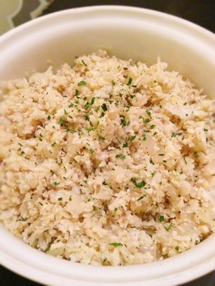

Not long after my husband and I started dating, we decided to cook dinner together. We went to the store and bought some fresh salmon.... and a bag of frozen mixed vegetables (not my idea). Only after we got home did we realize there was cauliflower in the mixed vegetables. We both professed our hatred for cauliflower....especially frozen cauliflower....from a bag. We never ate cauliflower again from that day on....until we became paleo.   
  
When you cut out a lot of the foods that you are used to eating, you come up with creative ways to re-create those foods. So one night we decided to suck it up and make cauliflower rice. And to our surprise, it was actually good! It has a texture very similar to rice, has a very mellow flavor, and mixes well in dishes that typically use rice. Some folks like it plain - just riced cauliflower and that is it. It is also great with some fresh squeezed lime and cilantro mixed in. I usually make it with onion, garlic and seasonings to give it some extra flavor...and because I have to add something.....anything else to it...because plain cauliflower still scares me just a little bit.

[6K+](http://www.pinterest.com/pin/create/button/?url=http%3A%2F%2Fwww.paleocupboard.com%2Fseasoned-cauliflower-rice.html&media=http%3A%2F%2Fwww.paleocupboard.com%2Fuploads%2F1%2F6%2F9%2F3%2F16939826%2F761897.jpg&guid=mTJcF9uV8aKK-0&description=Paleo%20Seasoned%20Cauliflower%20Rice%20-%20paleocupboard.com)

Please note that all recipes and images are the intellectual property of Paleo Cupboard and they may not be copied or distributed without consent.

|  |  |  |
| --- | --- | --- |
| Paleo Seasoned Cauliflower Rice  Prep time:  10 mins            Cook time: 10 mins           Servings: 4 | **44 Votes** | [Print Friendly and PDF](http://www.printfriendly.com/) |

**Ingredients:**- 1 head of cauliflower  
- 1/2 white onion, diced  
- 1 Tbsp. garlic, pressed  
- 2 Tbsp. coconut oil  
- 4 Tbsp. chicken broth  
- Dash sea salt  
- Dash ground pepper  
- Chopped parsley (optional)  
  
**Equipment:**- Chopping knife  
- Cutting board  
- Garlic press  
- Cheese grater or food processor  
- Large sauté pan  
- Stirring spoon  
  
**Directions:**1. Grate the cauliflower or pulse in food processor until it is rice shaped.   
2. Heat coconut oil in sauté pan over medium high heat. Sauté onion and garlic for about 3 minutes.  
3. Add cauliflower, stir well.  
4. Add chicken broth, sea salt and pepper. Saute for about 5 minutes until cauliflower is slightly tender.  
5. Place cauliflower in serving bowl and top with chopped parsley (optional). Serve.

